Banking performance visual analysis (R / ggplot2)

Problem Statement
A Call-Report-style panel lists bank-year-product rows from 1990–2024 with ROA, NIM, efficiency, NPL, assets, charter, and funding mix. The same Cookbook Ch. 2 question as FuelEcon_R: did profitability actually improve, or did the mix of institutions change? An all-rows mean after 2014 is inflated by Fintech / ILC (and some investment-bank) books. Credit, ALM, and the board need a traditional-commercial series, a size-vs-ROA check, and a name-level view — in R.

Solution Strategy
Same pipeline: acquire → import stringsAsFactors = FALSE → explore year/charter tables → repair funding blanks and flags → split–apply–combine year-mean ROA → ggplot2 point+smooth → subset Community+Regional+Money Center → relate log assets to ROA → melt/facet dual series → community boxplots and Core/Wholesale mix → Reduce(intersect) names present every year 1990–2014 → simulation knobs (year cut, include fintech, noise, subsample) → four audience paragraphs.

Solution
Panel: 2,550 rows × 16 columns, 54 banks, 1990–2024. All-institution mean ROA: 1.07% (1990) → 0.48% (2009) → 1.36% (2014) → 1.94% (2024). Traditional commercial only: 1.05% → 0.35% (2009) → 1.14% (2014) → 1.29% (2024). log-assets vs ROA mildly negative. Twelve commercial names appear every year 1990–2014. Community funding stays mostly core deposits after the crisis.
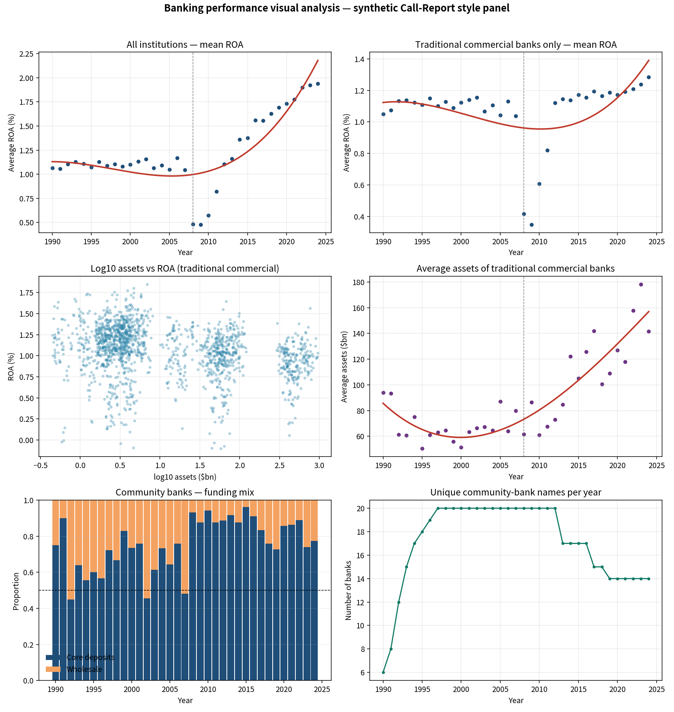
Figure. All-in vs traditional ROA, size scatter and assets over time, community funding mix, unique community names. The red all-in line after 2014 is not a community-bank story.

Key Takeaways
- Never brief pooled ROA without naming Fintech / ILC. Traditional commercial only partially recovered from 2008–09.
- Size is not the same as efficiency: larger books print slightly lower ROA in this panel.
- Funding mix for community rows is a liquidity story, not a profitability miracle.
- Type traps (blank funding, T flags) belong in the lab notebook before the board slide.
- Short name: BankEff_R. Teaching panel — not a Call Report filing.

